Recruiting Experience- Identifying/Tackling Unconscious Biases
By Keyanna Harper

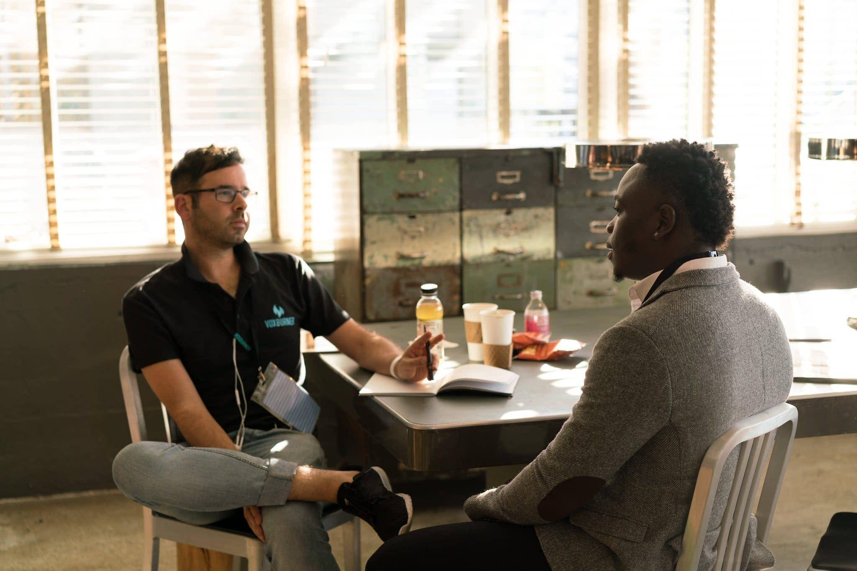
Have you ever walked into an interview as a complete nervous wreck? Subconsciously, you're hoping that every piece of hair is in place and that your recruiter doesn't judge you based on what you look like, your name, or what you were wearing. All you want to do is make sure you're answering the question correctly. I know I have.
When I was on the job search, I ran across a recruiter that made me want to get up and run. Fresh out of college, looking for my first big job, and I was excited! I walk in with all my confidence expecting to nail this interview. Boy, was I in for a treat.
I introduce myself, and we start right away. The questions begin to flow, and I answer them just as I practice. The recruiter turns to me and says, “ I see you have some experience, but it looks like your experience comes from an internship. I don't believe in internships. I think it's stupid you waste your time working for free, and because of that, I don't think you're cut out for the job, but I can offer you another job for lesser pay.
I was so upset but stayed calm. I explained that my internship was in a government position, and I was very qualified for this work. I was so offended. I declined the offer.
I walked out feeling so defeated. I couldn't believe he’d said that. As if what I'd learned and done didn't matter. Immediately I knew he was biased toward me, but he hadn’t realized his biased opinion turned away a hard-working person.

What is Unconscious bias?
Unconscious bias is an automatic response we have to different people or situations. It can be caused by how we were raised or our experiences with others.
Unconscious biases can be hard to recognize in ourselves because they're so deeply embedded into our subconscious minds that they become routine for us. We don't think about them consciously. It's not uncommon for a person who has been discriminated against to react unconsciously during the interview process.
Unconscious bias is only human nature, and we should not be offended by it; we should try to overcome and recognize our biases. It doesn't matter who you are. You have some unconscious biases. Every person assumes something about the next. Good training can help recruiters and job seekers battle these thoughts and choose a different approach.
It's important to know that unconscious biases are also prevalent in the workplace. While hiring managers tend to be more aware and intentional about their biases, candidates can also exhibit implicit bias during the interview process.
When it comes to addressing unconscious bias, there is no one-size-fits-all approach. But understanding how subtle differences between groups can affect their hiring processes. Understanding this can help everyone involved avoid making assumptions based on differences.

What Biases to Look Out For.
When it comes to unconscious biases, shape the perceptions of others. These biases can negatively impact people.
Here are some types of biases:
● Implicit bias is when you make assumptions about someone based on their identity without consciously intending to do so.
● Unconscious bias is when your brain unconsciously makes assumptions about someone based on their identity without consciously intending to do so.
● Stereotypes: This can include making broad generalizations about groups of people based on characteristics that aren't true for everyone within those groups.
To help you recognize some biases in yourself, here are some examples:
Appearance
Beauty bias: People who are attractive are more likely to be treated positively. From an early age, we are taught that good-looking people succeed in life.
Weight bias: Weight biases are negative judgments influenced by a person’s weight.
Height bias: Taller people are more likely to be perceived as authoritative and leader-like, whereas shorter individuals— particularly men— are more likely to encounter negative height bias.
Smoking bias: There is a double standard against smokers— they are judged most harshly by others if they smoke around nonsmokers in public places.
Ageism
Age discrimination is the unfair treatment of an individual based on their age. It’s a form of prejudice that may occur in the workplace, housing, and other areas.
Age bias can be especially harmful to older adults, who are often viewed as less valuable employees and consumers because they have less experience or are behind the times.
Name
Name biases are known to be the most significant bias. More Ethnic names tend to be passed over more often than Caucasian names.
Maternal
The maternal bias is most apparent when employers disregard working moms for salary bumps and promotions. According to a study by the American Association of University Women, mothers are paid roughly 80 cents for every dollar men are paid, and female employees with children earn less than women without children (even if they have the same job).

Here is a tweet thread that sparked some interest in how bias can affect your judgment.

Click here to see the thread.
.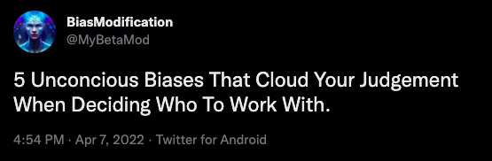

Click here to see the thread.
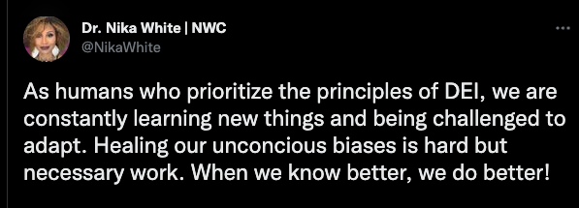

Tips on Identifying/Tackling Unconscious Biases
While it may be easy to assume that unconscious biases are limited to hiring managers and other decision-makers at work, they can also affect your recruiting experience as a job seeker. We must identify and correct them with positive action and educate ourselves on how to get past those biases. Here are a few tips to help identify and tackle those unconscious biases.

Utilize HR Technology: Many AI and tech tools are available that help aid companies and reduce unconscious bias during the recruiting process. Invest in an applicant tracking system that features blind screening to avoid concerns such as name bias or feature filters that allow qualifying factors to be highlighted. Even AI technology helps companies improve how job descriptions are constructed to avoid discouraging language and increase diverse hiring.

Create an effective scorecard: Create a scorecard for each interview stage. The scorecard should focus on the skills, experience, and traits needed for the job and company culture. Not only will this ensure consistency with predetermined questions, but you will also focus on the job requirements versus personal bias.

Continuously audit your interview process: Routinely review your interview process to align with the scope of the job and the skills needed to be successful. As job scopes change, so should the direction of your questions. Imagine asking a candidate interviewing for a sales development role about how to close deals when your organization's process changed six months ago to Account Managers closing. It may also be good to change the interviewees or add additional team members who can review candidate profiles or conduct interviews. Don't forget to use those scorecards to compare and discuss together.

Communicate your recruiting process - Candidates will appreciate an explanation of the recruitment journey. Not only does it allow them to understand what to expect, but it will also provide transparency, eliminating any uncertainty and perception of bias.

Here are a few TikToks about unconscious bias.
Click to watch the video.
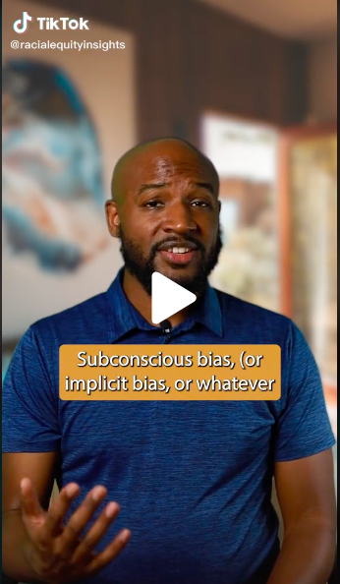

Click here to watch the video.
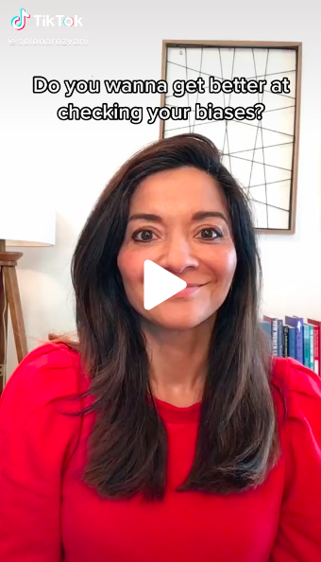

It is important to be aware of your own biases so that you can avoid perpetuating inequality in the workplace. By understanding how our beliefs influence our decision-making, we can begin to make changes that will lead to a more diverse and inclusive workplace.

